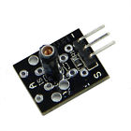

# **Standard Vibration Switch Module Vibration SW-18015P Sensor For Arduino**

100% brand new and high quality

Name: vibration switch

Quantity:1pc

Humidity: Random

Size: 18mm×15mm/0.71"×0.59"(approx)

This switch is OFF in the resting state, when the external force to touch and to achieve a proper vibration, meet the appropriate speed or from the (partial) heart, conductive pin will momentarily conduction (ON) status, make changes in electric property, and disappear when the external force electric property open (OFF) state is restored.

Omnidirectional, any Angle can trigger job

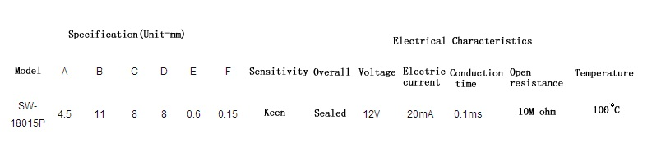

Vibration Switch Module

Vibration Switch Module and number 13 comes with LED build a simple circuit to produce vibration flasher. Use digital 13 interface comes with the LED. The vibration sensor connected digital 3 interfaces. When the vibration sensor senses detected the key signal. LED flashes.

Routines source code:

int Led=13;// define LED Interface

int Shock=3// define the vibration sensor interface

int val;// define numeric variables val

void setup()

{ pinMode(Led,OUTPUT);// define LED as output interface

pinMode(Shock,INPUT);// define vibration sensor as output interface

}

void loop()

{

val=digitalRead(Shock);// digital interface will be assigned a value of 3 to read val if(val==HIGH)// when the vibration sensor detects a signal, LED flashes

{ digitalWrite(Led,LOW);

}

else

{ digitalWrite(Led,HIGH);

}

}